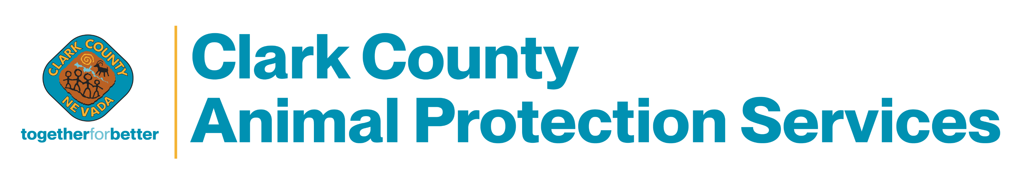
FOR CONSERNS ABOUT THE WELFARE OF ANIMALS IN THIS ESTABLISHMENT
CALL 702-455-7710

REPORT TO ENSURE THEIR SAFETY & WELL BEING

